ghfamilydentistry.com Content Management System Instructions

Link: [ghfamilydentistry.com/admin](https://ghfamilydentistry.com/admin)

Developer Contact Info:

Colin Knebl

616-402-2095

colin.knebl@outlook.com

The Content Management System (CMS) is used to update the content on ghfamilydentistry.com. Much of the visible content on the website is editable (services, downloadable forms, staff members/images, etc.).

This purpose of this document is to provide a reference when updating content on ghfamilydentistry.com. If you have any questions when updating any of the content, please reach out to Colin.

**Example 1, update office hours**

**Step 1**. In the ‘Content’ column on the left hand side of the screen click on ‘Office Hours’.

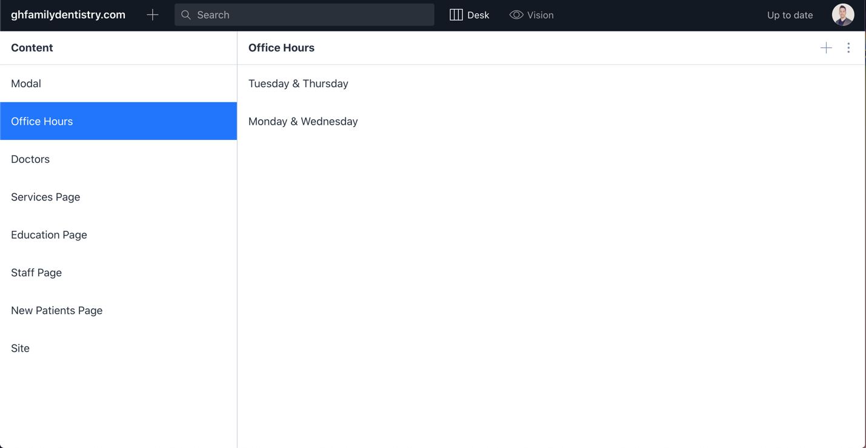

**Step 2**. Click the appropriate days to update, ‘Tuesday & Thursday’ or ‘Monday & Wednesday’ (‘Tuesday & Thursday’ was selected in the image).

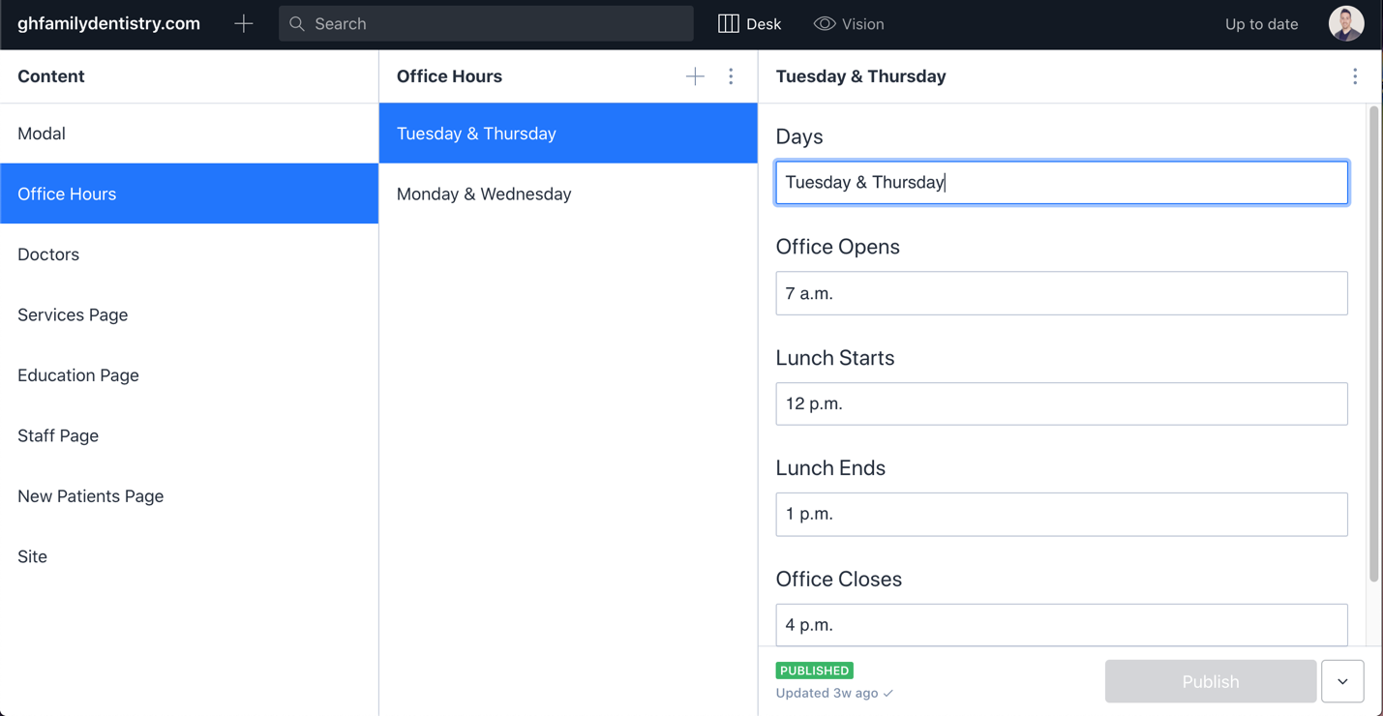

**Step 3**. Update the hours as desired (hours on the website will be displayed exactly as entered).

**Step 4**. Once hours are correctly entered, click the blue ‘Publish’ button at the bottom right.

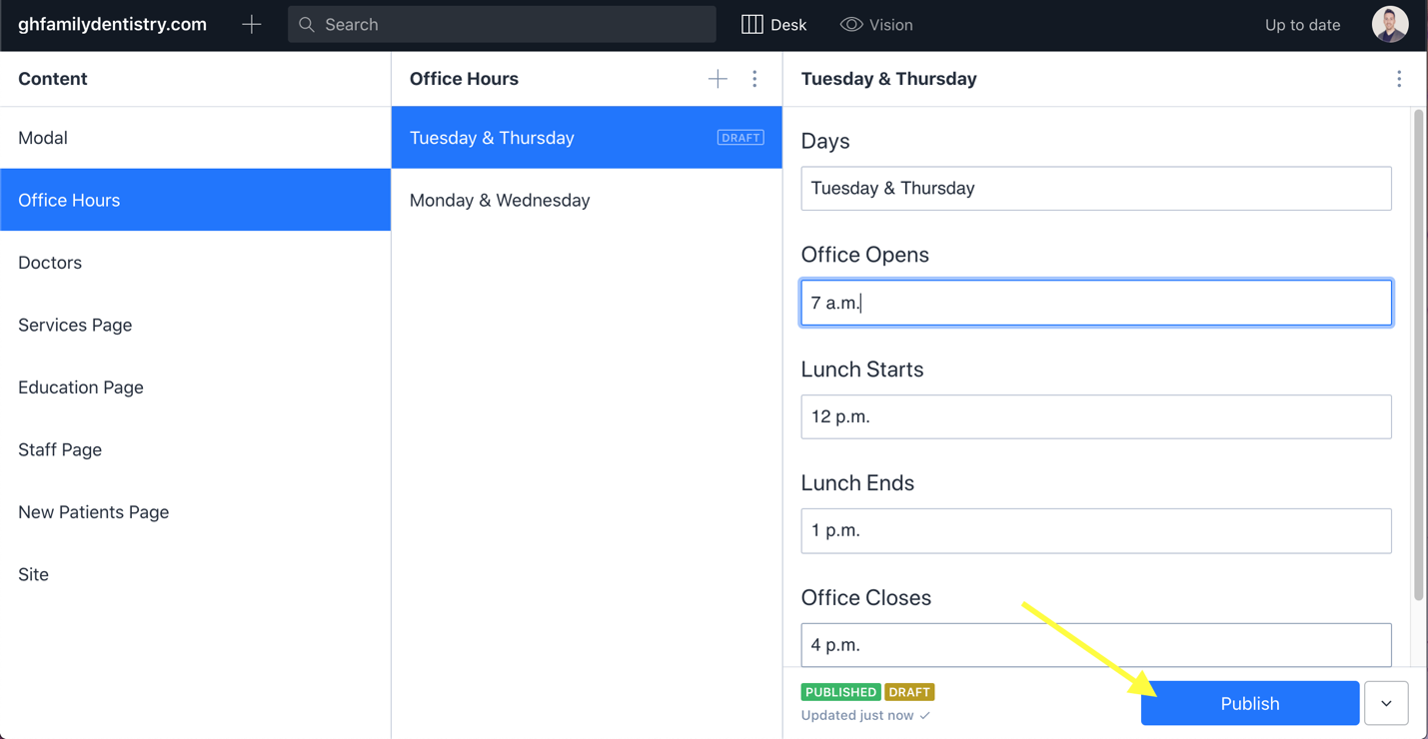

**Step 5**. Wait. The website should reflect the updated times after 5-10 minutes. If the website is not updated after ~30 minutes, let Colin Knebl know, and he will troubleshoot the issue.

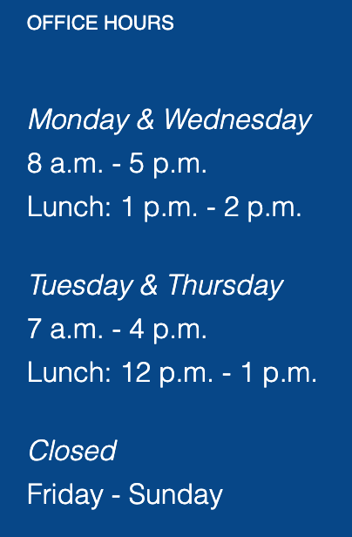

**Example 2, update site modal**

A modal is a pop-up that appears on the screen.

**Step 1**. In the ‘Content’ column on the left hand side of the screen click on ‘Modal’.

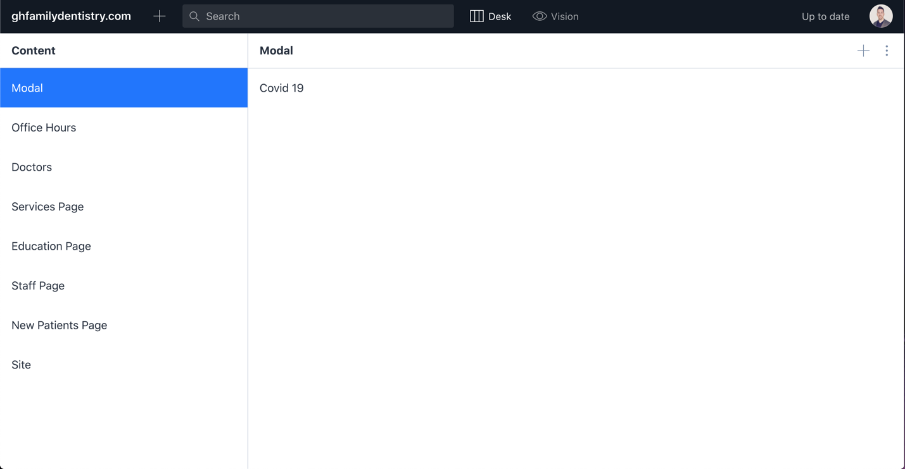

**Step 2**. Select the modal to update (only one is listed *Covid 19*), or select the plus button in the upper right corner to create a new modal (the plus button was selected in the example).

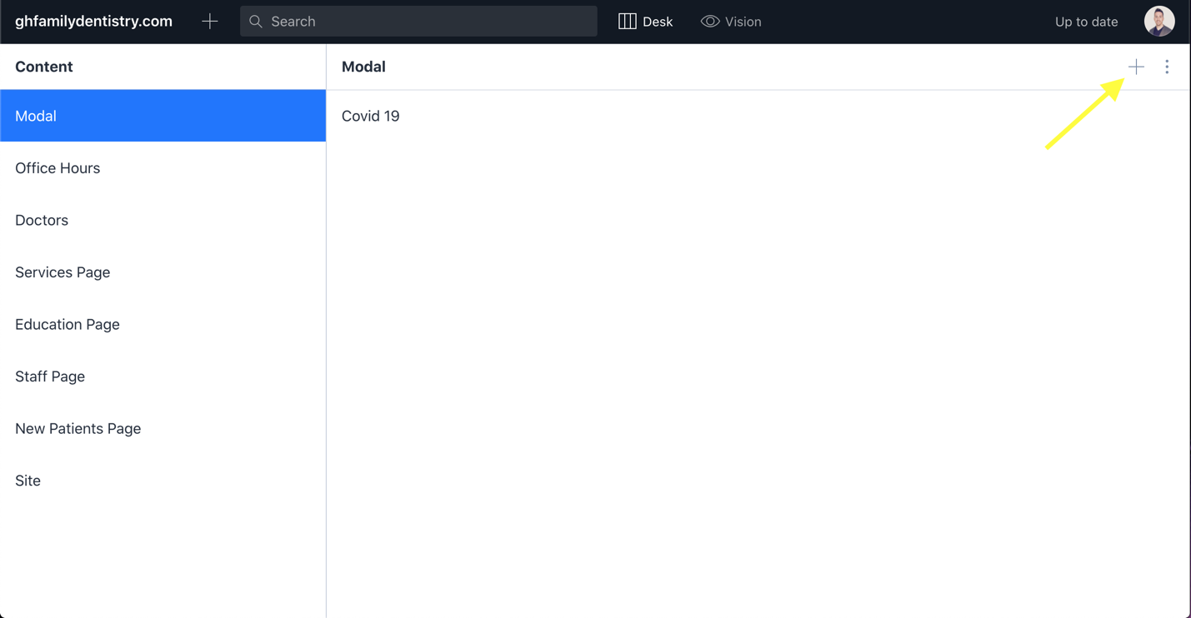

**Step 3**. Update/enter the modal information (title, an optional image, and content).

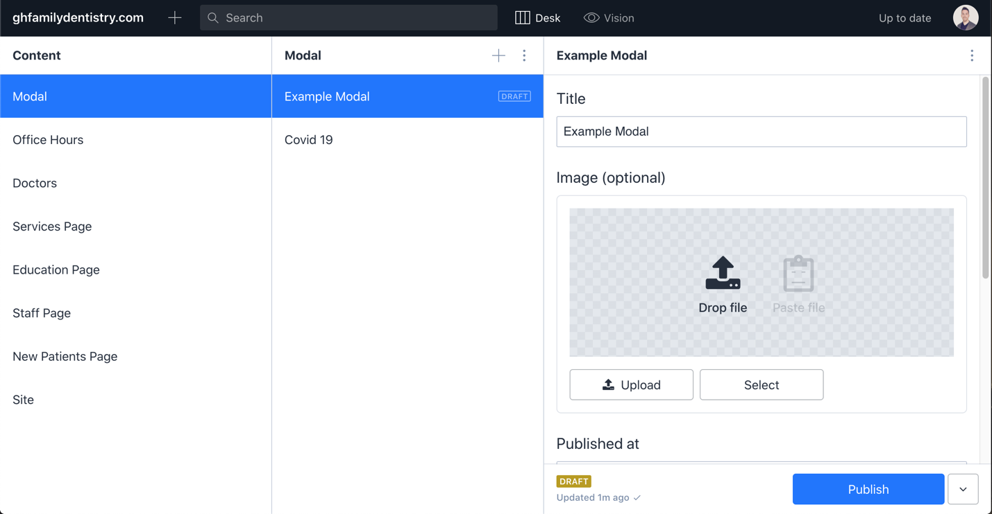

**Step 4**. Once the modal information has been updated/entered, click the ‘Publish’ button in the bottom right.

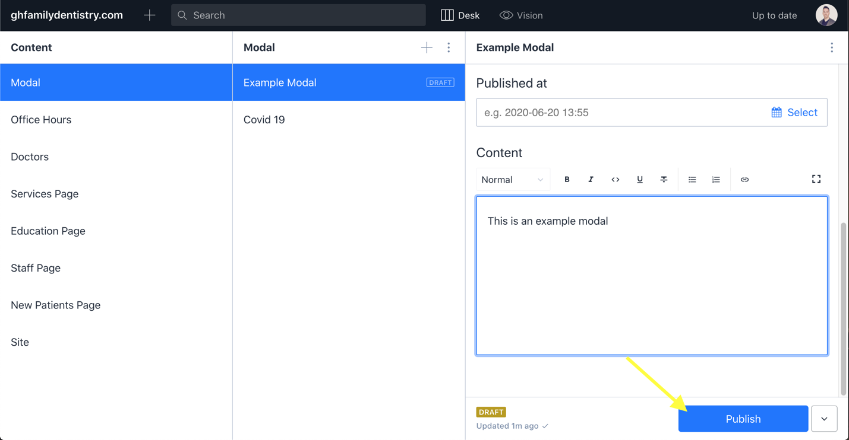

**Step 5**. Select the desired modal. From the ‘Content’ column on the left side of the screen, select ‘Site’.

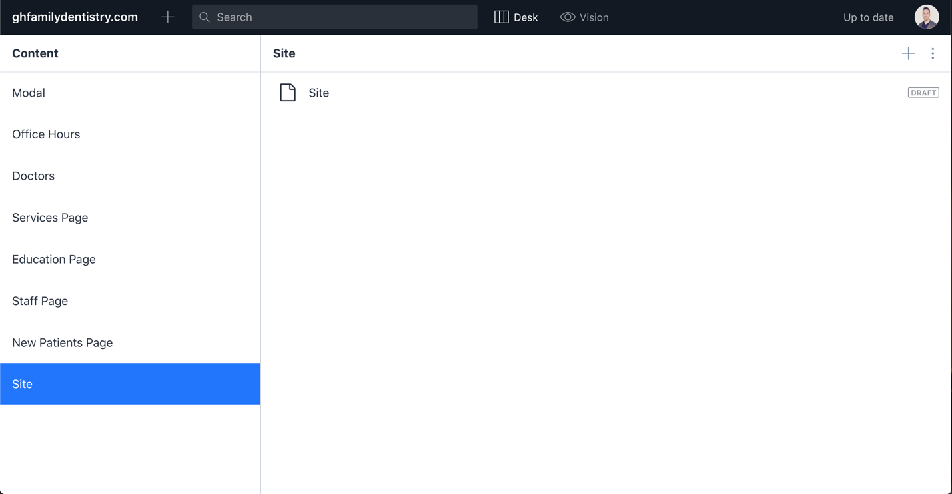

**Step 6**. Select ‘Site’ again. This section of the CMS contains site wide configuration details.

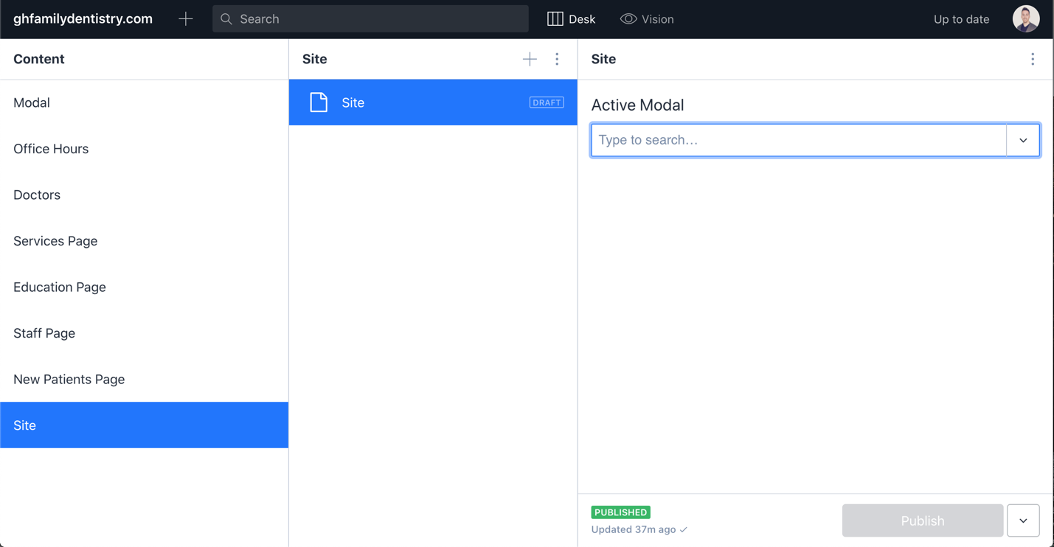

**Step 7**. From the ‘Active Modal’ dropdown, select the modal to display. You should see an option for the modal that was just created, as well as all previous modals.

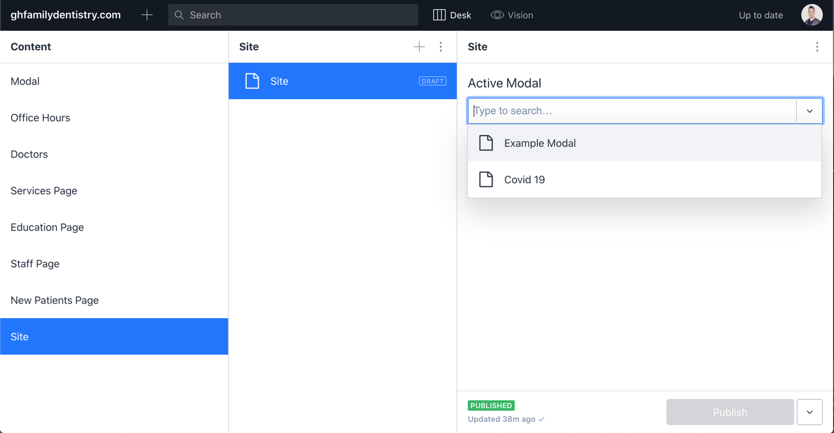

**Step 8**. Once selected, click ‘Publish’ at the bottom right

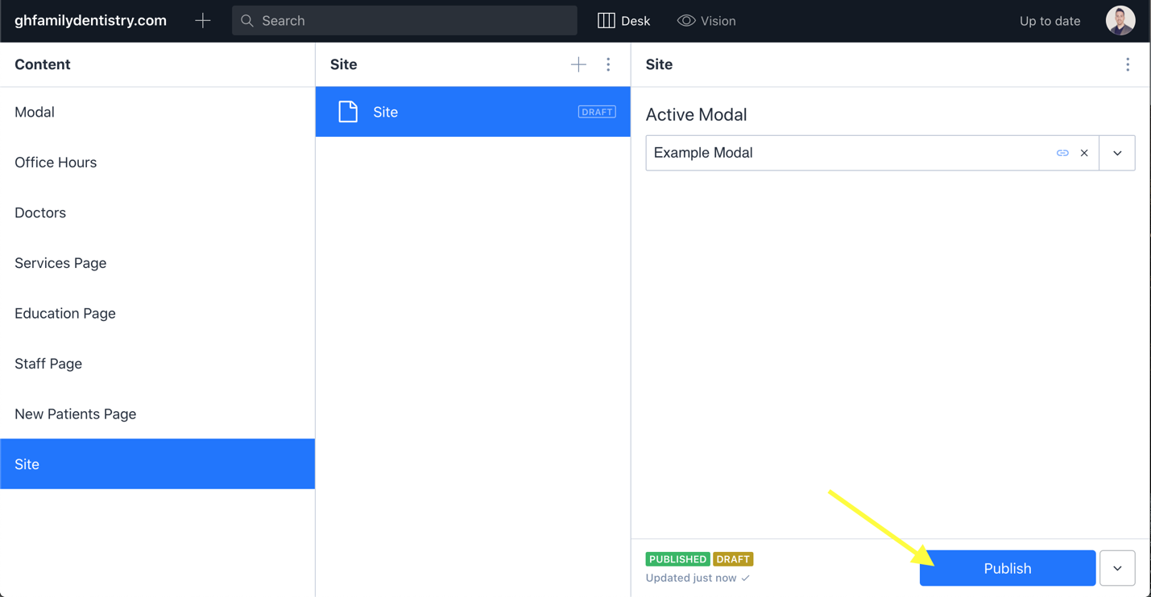

**Step 9**. Wait. The website should display the new/updated modal within 5-10 minutes. If the website is not updated after ~30 minutes, let Colin Knebl know, and he will troubleshoot the issue.

